Outcomes Benchmarking

Guidance
Academic Year 2016-17 Data

Authors: Bob Denman
Steve Johnson

Date: February 2018

Version: P2

Status: For Publication

This report was prepared using funding provided by the Department for Education under contract with NatSIP, the National Sensory Impairment Partnership:

Contact:
Lindsey Jane Rousseau, NatSIP Facilitator
T: 07711 030711
E: lindsey.rousseau@natsip.org.uk
W: www.natsip.org.uk

Copyright © NatSIP 2017

This document is copyright © NatSIP 2017, and is licensed under a Creative Commons Attribution-ShareAlike 4.0 International License. For more details please see http://creativecommons.org/licenses/by-sa/4.0/
You are free to share — copy and redistribute the material in any medium or format, adapt — remix, transform, and build upon the material for any purpose, even commercially, under the following terms:
Attribution — You must give appropriate credit, provide a link to the license, and indicate if changes were made. You may do so in any reasonable manner, but not in any way that suggests the licensor endorses you or your use.
Share Alike — If you remix, transform, or build upon the material, you must distribute your contributions under the same license as the original.
No additional restrictions — You may not apply legal terms or technological measures that legally restrict others from doing anything the license permits.

Table of Contents
0.2 Revision history 5
0.3 Document approvals 5
0.4 Preface 6
0.5 Abbreviations 6
1.0 Overview 7
1.1 What is the NatSIP Outcomes Benchmarking exercise? 7
1.2 How many LAs participate? 7
1.3 How can participating benefit services? 7
1.4 When is it carried out? 7
1.5 What data is sought? 7
1.6 How do services obtain the data? 8
1.7 How is it reported? 8
2.0 Process summary 9
3.0 Data collection 10
3.1 Defining the population 10
3.2 Classification of sensory impairments 11
4.0 Performance indicators and data required 12
4.1 Categories of SI 12
4.2 General points 13
4.3 Specification of the performance indicators and data required 14
4.3.1 End of Early Years Foundation Stage 14
4.3.2 End of Key Stage 1 16
4.3.3 End of Key Stage 2 17
4.3.4 End of Key Stage 4 21
4.3.5 End of EYFS, KS1, KS2 and KS4 combined 24
4.3.6 Post-16 (Year 12) 25
5.0 Data entry and submission 26
5.1 OBMRS 26
5.1.1 How to apply for a token if you don’t have one 26
5.1.2 Your token – Email ‘T’ 29
5.1.3 OK – I have Email ‘T’ and a token. How do I access OBMRS? 29
5.1.4 The link doesn’t work when I click on it… 29
5.2 The first OBMRS screen 31
5.3 What if I have data for more than one LA? 32
5.4 What if I need to do a return for a single impairment/team? Can I do a partial return? Can we do multiple partial returns for a single LA? 32
5.5 What sections of the return do I need to complete? 33
5.6 Question A9: Tell us about others who may be making partial returns for the same LA 33
5.7 Incomplete returns 34
5.8 The on screen font size is too small…too large… 34
5.9 Data entry convention 34
5.10 What happens when I start inputting data? 35
5.10 Stepping through the pages of each section 36
5.11 Mandatory questions 36
5.12 Saving your data input without submitting 37
5.13 Picking up where you left off 37
5.14 Navigating the return - The Question Index 38
5.16 The final question – or how not to submit without meaning to… 38
5.17 Submitting your return 39
5.18 Help! I didn’t mean to press submit! 39
5.19 When is the submission deadline? 39
6.0 How will the results be reported? 40
6.1 Contents of the NatSIP report 40
6.2 Treatment and presentation of the data 40
6.3 Service results 40
6.4 Directory 40
6.5 When will the main report be made available? 40
6.6 Summary report 40
7.0 Confidentiality and data security 41

0.2 Revision history
Date | Version | Description | Author
10 Aug 2017 | 1 | First draft | Bob Denman (BD)
23 Aug 2017 | 2 | Second draft | BD
07 Sept 2017 | 3 | Third draft | BD and Steve Johnson (SJ)
11 Sept 2017 | 4 | Fourth draft | BD and SJ
12 Sept 2017 | 5 | Revised screenshots and text + new section on QI | SJ
13 Sept 2017 | 5 | Revised section 5 | SJ
14 Sept 2017 | 6 | PI 10 amendment and proof read | BD

0.3 Document approvals
This document requires the following approvals:
Name | Role
Bob Denman | Workstream Co-Lead
Nicky Ereaut | Workstream Co-Lead
Lindsey Jane Rousseau | NatSIP Facilitator
NatSIP Reference Group

0.4 Preface
This Guidance document has been prepared for the 2016-17 academic year data NatSIP Outcomes Benchmarking exercise, and supersedes the Guidance document for the previous exercises. This document aims to provide all the details that local authority sensory support services will need for their participation.
Continuity of data from year to year is important for considering trends and all of the performance indicators in the current exercise were present in last year’s dataset. However, two of the performance indicators relating to GCSEs have been suspended for this year, as they are no longer included within the DfE’s assessment and reporting arrangements.
Data submission will again be performed through the online, web-based Outcomes BenchMarking Returns System (OBMRS), following its broadly welcomed and successful introduction last year.

0.5 Abbreviations
The following abbreviations have been used in this document:
Abbreviation | Expansion
CA | Chronological age
CYP | Children and young people
CVI | Cerebral vision impairment
DfE | Department for Education
EYFS | Early Years Foundation Stage
ELG | Early Learning Goal
GLD | Good Level of Development
HI | Hearing impairment
KS | Key Stage
LA | Local Authority
MSI | Multi-sensory impairment (Deaf blindness)
NARA | Neale Analysis of Reading Ability (Braille version)
NatSIP | National Sensory Impairment Partnership
NC | National Curriculum
OBMRS | Outcomes BenchMarking Returns System
PI | Performance indicator
SEN | Special educational needs
SI | Sensory impairment
SLD/PMLD | Severe learning difficulties/Profound and multiple learning difficulties
VI | Vision impairment

1.0 Overview

1.1 What is the NatSIP Outcomes Benchmarking exercise?
• NatSIP Outcomes Benchmarking is an annual exercise, first completed in 2011.
• It involves services collecting and submitting data on CYP with SI on a range of performance indicators, mainly, but not exclusively, related to educational achievement/progression.
• Its main purpose is to provide reliable data for use by LA sensory support services to evidence their impact and inform development needs.
• From its inception the exercise has attracted significant interest and financial support from the DfE.
• The NatSIP Outcomes Benchmarking Workstream is co-led by Nicky Ereaut (Specialist Manager for Sensory, Physical & Complex Needs, Oxfordshire) and Bob Denman (NatSIP Associate).

1.2 How many LAs participate?
• Over 100 LAs have participated in each of the last two of the seven exercises so far completed.

1.3 How can participating benefit services?
A range of applications have been reported by services including:
• Data management e.g. establishing or improving systems for tracking and monitoring pupil progress.
• Service reporting e.g. to line managers within the LA.; to Health and Wellbeing Boards/Local Joint Strategic Needs Assessments; to Ofsted.
• Continuing professional development e.g. service discussion and reflection; INSET.
• Quality assurance e.g. contributing to the review/evaluation of service/SI provision; using the data in relation to the NatSIP Quality Improvement Pack (DfE 2014).
• Service development planning

1.4 When is it carried out?
• The exercise is launched in early September and services will have until the end of February 2018 to gather and submit their data to NatSIP.

1.5 What data is sought?
• Data from the previous academic year (AY 2016-17) is sought on pupils with HI, VI and MSI on a set of performance indicators spanning the EYFS to Post-16.
• For HI and VI separate data is sought for pupils with mild, moderate, severe and profound sensory loss. Data for pupils with MSI is sought without any differentiation according to severity of sensory impairments.
• For HI, data for pupils with and without cochlear implants is sought at the EYFS. For VI, data is differentiated between Braille users and those that do not use Braille throughout the exercise.
• Services do not have to have to collect all the cohorts of data to participate in the exercise.

1.6 How do services obtain the data?
Services typically collect the data from any or a combination of:
• Their service/pupil records
• LA information management teams
• Schools

1.7 How is it reported?
A detailed report is circulated to all participants by the end of June at the latest. Prompt submission of data by the end of February 2018 from all services intending to make a return should enable the report to be released in the first half of the summer term. Circulation of the full report is restricted to participants. Each service/LA also receives a confidential copy of its own results, and a directory of participants to facilitate contact, networking and discussion.
The report provides:
• Extensive benchmarking data against which services can compare their results
• A comparison of HI, VI and MSI results
• Trend data through a comparison of year on year results
• A comparison of the NatSIP outcomes data with that for all CYP in England published by the DfE

2.0 Process summary
The diagram below outlines the tasks that Services will need to undertake (to be followed by report preparation and circulation through NatSIP):

Preparation (September 2017 onwards)

    - Read the Guidance document for familiarisation

    - Access the online Outcomes BenchMarking Returns System (OBMRS) for familiarisation

    - Identify the cohorts of pupils within the LA which will be the focus of data collection [ref. sections 3.1, 3.2, 4.1 & 4.2]

    - Check the pupil data required for each of the performance indicators
[ref. section 4.3]

    - Plan how the data will be collected

Data collection (September 2017 – February 2018)

    - Collect the specified data on the identified cohorts of pupils from the identified sources [ref. section 4.3]

Data entry and submission (any time up to the end of February 2018)

    - Enter the collated pupil data within the identified cohorts into the online OBMRS as appropriate (HI, VI, MSI) [ref. section 5]. Data entry can be carried out and saved over time

    - Click ‘Submit’ on the OBMRS to make your online return when you have entered all the valid data that you have been able to collect by the end of February 2018

3.0 Data collection

3.1 Defining the population
To obtain reliable benchmarking data it is important that the population data is clearly defined. The overall population of CYP with SI which forms the focus of the NatSIP 2016-17 academic year data Outcomes Benchmarking exercise is defined by the following criteria in conjunction with the detailed classification of sensory impairments provided in section 3.2:
• CYP with HI
CYP from the Foundation Stage to Post-16 with a permanent hearing loss that is at least mild in degree. CYP with a unilateral hearing loss are not included.
• CYP with VI
CYP from the Foundation Stage to Post-16 with a vision impairment that is at least mild in degree. CYP whose vision can be appropriately corrected are not considered to be vision impaired. CYP with monocular vision who have normal vision (corrected as appropriate) in the unaffected eye are not included.
• CYP with MSI
CYP from the Foundation Stage to Post-16 with a multi-sensory impairment who have been diagnosed as deaf blind (ref. section 3.2 for definition/description).
• CYP with additional special educational needs
CYP may have additional SEN but those with severe learning difficulties or profound and multiple learning difficulties (SLD/PMLD) are not included. CYP with SLD/PMLD will typically attend special schools for those with the most severe and complex needs.
• CYP’s residence and educational placement
All CYP resident within the LA, who are the responsibility of the LA and who meet the above criteria are included, regardless of the educational setting they attend and where this is located.

3.2 Classification of sensory impairments
The classification of HI and VI shown in Table 1 has been adopted for the benchmarking exercise.
With regard to VI, the classification applies to corrected vision with both eyes open. Acuity criteria are for guidance purposes only. The professional judgement of a QTVI should be applied as necessary to decide on the classification. For example, a CYP may have a mild reduction in visual acuity but be functioning within a different visual category due to an additional ophthalmic condition, e.g. an oculomotor disorder such as nystagmus; visual field reduction; cerebral vision impairment (CVI).
With respect to MSI, for the purposes of the 2016/17 academic year data exercise, the following definition/description of MSI has been adopted:

MSI is a functional term that is frequently used alongside or interchangeably with deaf blindness by educationalists, teachers and families because it communicates more effectively the impact of deaf blindness.
The Policy Statement Pupil Level Annual School Census Definitions (PLASC), published by the DfES (2005), states that: [pupils with MSI] have a combination of visual and hearing difficulties. They are sometimes referred to as deaf blind but may have some residual sight and or hearing. Many also have additional disabilities but their complex needs mean that it may be difficult to ascertain their intellectual abilities.
For the purposes of the NatSIP Outcomes Benchmarking exercise:
MSI/deaf blindness applies where a child or young person has combined vision and hearing impairments which create difficulty in accessing the curriculum and engaging in daily life experiences.
Whilst pupils with MSI/deaf blindness range from those mildly affected to those who are profoundly deaf and vision impaired, it is not necessary for sensory support services to differentiate between pupils by degree of sensory impairment in their data submissions (unlike the requirement for pupils with HI or VI).
Children and young people with severe learning difficulties/profound and multiple learning difficulties are not included.
A pupil whose vision can be appropriately corrected is not considered to be vision impaired.

Table 1: Classification of sensory impairments

Sensory loss |  | Classification
Degree | Type
Mild | HI | Unaided threshold 21-40 dBHL in the better ear
 | VI | Best corrected vision: within the range 6/12 – 6/18 Snellen/Kay (LogMAR 0.3 – 0.48)
Moderate | HI | Unaided threshold 41-70 dBHL in the better ear
 | VI | Best corrected vision: less than 6/19 – 6/36 Snellen/Kay (LogMAR 0.5 – 0.78)
Severe | HI | Unaided threshold 71-95 dBHL in the better ear
 | VI | Best corrected vision: less than 6/36 – 6/120 Snellen/Kay (LogMAR 0.8 – 1.3)
Profound | HI | Unaided threshold in excess of 95 dBHL in the better ear
 | VI | Best corrected vision: less than 6/120 Snellen/Kay (LogMAR 1.32+)
Any | MSI | CYP who meet the above definition/description of MSI/deaf blindness

4.0 Performance indicators and data required
The set of 14 PIs adopted for the NatSIP 2016-17 academic year data Outcomes Benchmarking exercise and the data required for entry into the online OBMRS are set out in s4.3, following clarification on the SI categories for data collection (s4.1) and some general points of guidance (s4.2).

4.1 Categories of SI
Data will be collected for each of the categories of SI within Table 2 below:

Table 2: SI categories for data collection

HI | VI | MSI
Mild HI | Mild VI | MSI  (all pupils with MSI/deaf blindness excepting those with SLD/PMLD)
Moderate HI | Moderate VI
Severe HI  (Sub-divided into pupils with and without cochlear implants at the EYFS) | Severe VI  (Sub-divided into Braille users and non-Braille users)
Profound HI  (Sub-divided into pupils with and without cochlear implants at the EYFS) | Profound VI  (Sub-divided into Braille users and non-Braille users)

4.2 General points
In the data collection process, account should be taken of the following guidance:
• Academic year
The data to be collected relates to the 2016-17 academic year.
• Individual Pupil Data Forms
To help sensory support service personnel in collecting the required data on individual pupils, individual pupil data Forms for HI, VI and MSI are available from the NatSIP web site. If you are not yet registered on the NatSIP website, registration is free and open to all.
The use of these particular forms is entirely optional; services may use them internally, but should not return them to NatSIP.
• CYP with cochlear implants
With regard to CYP with HI, for the EYFS performance indicators (i.e. PI Nos. 1 and 2) services are asked to differentiate between children who have had a cochlear implant and the rest of the cohort in their data submissions.
The criterion for cochlear implants is that the children identified must have received implants and had their first tuning by the age of 2 years 0 months. The implants may be either unilateral or bilateral.
• CYP who are Braille users
For the VI population, services are asked to differentiate between Braille users and non-Braille users for those with severe or profound VI in their data submissions for each of the PIs (except for PI 4 which is for Braille users only).
The criterion for Braille users is that the CYP identified used Braille during 2016-17 to access the majority of their reading materials and as the main means of recording their work. Decisions about those who used a mixture of large print and Braille will be dependent on the method they used for the majority of the time.
Note: For the Braille only outcome (PI 4) concerned with Braille Reading at Year 6, there is a further stipulation that the children will have been engaged in pre-Braille/Braille learning from Foundation Stage 1 (Reception). This is to prevent children who have been more recently introduced to Braille (e.g. because of a deteriorating condition), from being included in this particular PI.
• CYP with CVI
CYP with CVI (or other visual factors such as visual field loss or nystagmus) who have a functional mild, moderate, severe or profound vision impairment, regardless of their visual acuity, are included within the NatSIP Outcomes Benchmarking datasets.
• CYP with MSI
Unlike the case for CYP with HI and CYP with VI, for CYP with MSI (as stated in Table 2), services are not asked to differentiate according to the degree of sensory loss. Also, services are not asked to identify those with cochlear implants or CYP who use Braille within the MSI population.
• Chronological age and National Curriculum year
CYP who have been placed in a NC year which does not correspond to their CA should be counted within the NC Year population and not their CA year population.
• LA Information Management Teams
Sensory support services often seek required data from their LA Information Management Teams. It is advised that these teams are provided with access to the Outcomes Benchmarking Guidance document to ensure that they interpret requests accurately.
• Calculation of performance indicator values
Services are not required to calculate performance indicator values. OBMRS has been programmed to perform and display these calculations automatically.

4.3 Specification of the performance indicators and data required
The generic term ‘(sensory) impairment’ has been used for brevity throughout the specifications of the PIs and data required. Each of the SI categories listed in Table 2 above can therefore be substituted for ‘(sensory)’ in the NatSIP PI specifications in the process of data collection.
To provide help in the interpretation of the PI data required, each key stage set of PIs is prefaced, where appropriate, by relevant information from the DfE‘s 2017 assessment and reporting arrangements.

4.3.1 End of Early Years Foundation Stage
DfE reference: 2017 EYFS assessment and reporting arrangements
Assessment rating | EYFS judgement
1 | Indicates a pupil who is at the ‘emerging’ level at the end of the EYFS
2 | Indicates a pupil who is at the ‘expected’ level at the end of the EYFS
3 | Indicates a pupil who is at the ‘exceeding’ level at the end of the EYFS
The assessment and reporting arrangements apply to all early years settings, including all providers registered with a childminder agency, all providers on the early years register, maintained schools, including maintained special schools, academies, free schools, Service Children’s Education (SCE) schools, non-maintained schools and independent schools with early years provision, unless they have an exemption.

4.3.1.1 NatSIP PI No 1
Key Stage | PI No | Performance Indicator | Data Required
End of EYFS | 1 | % of children with (sensory) impairment achieving the 17 Early Learning Goals in the EYFS Profile at an ‘expected’ level or ‘exceeding’ level | Number in the cohort (N):  Enter the number of children with (sensory) impairment for whom the LA was responsible who completed the EYFS and for whom the EYFS Profile Early Learning Goals data was reported by schools
Score: Number achieving the 17 Early Learning Goals in the EYFS Profile at an ‘expected’ level or ‘exceeding’ level
Identify the number of children in the cohort who achieved the ‘expected’ level or ‘exceeding’ level of achievement in each of the 17 Early Learning Goals
 |  |  | Possible score range: integers (whole numbers) from 0 to N

4.3.1.2 NatSIP PI No 2
Key Stage | PI No | Performance Indicator | Data Required
End of EYFS | 2 | % of children with (sensory) impairment achieving the Communication and Language area of learning of the EYFS Profile at an ‘expected’ level or ‘exceeding’ level | Number in the cohort (N):  Enter the number of children with (sensory) impairment for whom the LA was responsible who completed the EYFS and for whom the EYFS Profile Early Learning Goals data was reported by schools
Score: Number achieving the Communication and Language area of the EYFS Profile at an ‘expected’ level or ‘exceeding’ level
Identify the number of children in the cohort who achieved the ‘expected’ level or ‘exceeding’ level of achievement in all 3 elements (Listening and attention, Understanding, and Speaking) of the Communication and Language area of learning
 |  |  | Possible score range: integers (whole numbers) from 0 to N

4.3.2 End of Key Stage 1
DfE reference: 2017 Key stage 1 assessment and reporting arrangements
The assessment and reporting arrangements apply to maintained schools, including maintained special schools, academies, free schools, Service Children’s Education (SCE) schools and participating independent schools with pupils in KS1.
The 2017 phonics screening check threshold mark is 32. Teachers should check each pupil’s mark against the threshold to establish whether they have achieved the expected standard.

4.3.2.1 NatSIP PI No 3
Key Stage | PI No | Performance Indicator | Data Required
End of KS1 | 3 | % of children with (sensory) impairment at the end of KS1 achieving the ‘expected’ standard of phonic decoding | Number in the cohort (N):  Enter the number of children at the end of KS1 with (sensory) impairment for whom the LA was responsible
Score: Number achieving the expected standard of phonic decoding
Identify the number of children in the cohort who achieved the threshold mark of 32 or above in the phonic screening check by the end of KS1. Include the Year 2 children who achieved the ‘expected’ standard of phonic decoding in Year 1 as well as those re-checked or taking the test for the first time in Year 2. Do not include the cohort of children in Year 1 in 2016/17
 |  |  | Possible score range: integers (whole numbers)from 0 to N

4.3.3 End of Key Stage 2
DfE ref. (where applicable): 2017 DFE Key stage 2 assessment and reporting arrangements
The assessment and reporting arrangements apply to maintained schools, including maintained special schools, academies, free schools, Service Children’s Education (SCE) schools and participating independent schools and non-maintained special schools with pupils in KS2.
For the KS2 tests a scaled score of 100 will always represent the ‘expected standard’.
(In relation to PI 5)…The percentage of pupils achieving the expected standard is a combined measure across the three subjects. To be counted towards the measure, a pupil must have a scaled score of 100 or more in reading and mathematics; and have been teacher assessed in writing as ‘working at the expected standard’ or ‘working at greater depth in the expected standard’.
(In relation to PI 6)…The percentage of pupils achieving at a ‘higher standard’ is also a combined measure across the three subjects. To be counted towards the measure, a pupil must have a ‘high scaled score’ of 110 or more in reading and mathematics; and have been teacher assessed in writing as ‘working at a greater depth’.
In relation to PI 7, a child’s progress score in English reading is the difference between their own key stage 2 result and the national average KS2 result for their prior attainment group.
For details on how an individual child’s progress score in English reading from the end of KS1 to the end of KS2 is calculated, refer to: Primary school accountability in 2017. A technical guide for primary maintained schools, academies and free schools. Department for Education August 2017.

4.3.3.1 NatSIP PI No 4
Key Stage | PI No | Performance Indicator | Data Required
End of KS2 | 4 | % of Braille users in Year 6 with age appropriate or better Braille Reading scores on the Neale Analysis of Reading Ability (NARA) | Number in the cohort (N):  Enter the number of children with vision impairment in Year 6 who have been engaged in pre-Braille/Braille learning since Foundation Stage 1 (Reception)
Scores:
4.1 Number with age appropriate or better NARA Reading Accuracy scores
Enter the number of children in the cohort who have a NARA Reading Accuracy score which is equal to or higher than 3 months below their CA
4.2 Number with age appropriate or better NARA Reading Comprehension scores
Enter the number of children in the cohort who have a NARA Reading Comprehension score which is equal to or higher than 3 months below their CA
4.3 Number with age appropriate or better NARA Reading Speed scores
Enter the number of children in the cohort who have a NARA Reading Speed score which is equal to or higher than 3 months below their CA
4.4 Number with age appropriate or better scores on all of the NARA scales
Enter the number of children in the cohort who have NARA scores on all of the scales (Accuracy, Comprehension & Speed) which are equal to or higher than 3 months below their CA
 |  |  | Possible score ranges: Integers (whole numbers) from 0 to N for each of 4.1, 4.2, 4.3 and 4.4

4.3.3.2 NatSIP PI No 5
Key Stage | PI No | Performance Indicator | Data Required
End of KS2 | 5 | % of children with (sensory) impairment achieving the ‘expected’ standard or above across English reading, English writing and mathematics | Number in the cohort (N):  Enter the number of children with (sensory) impairment at the end of KS2 for whom the LA was responsible whose achievement at the end of KS2 in English reading, English writing and mathematics could be determined from the results reported by schools
Score: Number achieving the ‘expected’ standard or above across English reading, English writing and mathematics
Enter the number of children in the cohort achieving the ‘expected’ standard or above across English reading, English writing and mathematics
 |  |  | Possible score range: integers (whole numbers) from 0 to N

4.3.3.3 NatSIP PI No 6
Key Stage | PI No | Performance Indicator | Data Required
End of KS2 | 6 | % of children with (sensory) impairment achieving at a ‘high’ standard across English reading, English writing and mathematics | Number in the cohort (N):  Enter the number of children with (sensory) impairment at the end of KS2 for whom the LA was responsible whose achievement at the end of KS2 in English reading, English writing and mathematics could be determined from the results reported by schools
Score: Number achieving at a ‘high’ standard across English reading, English writing and mathematics
Enter the number of children in the cohort achieving at a ‘high’ standard across English reading, English writing and mathematics
 |  |  | Possible score range: integers (whole numbers) from 0 to N

4.3.3.4 NatSIP PI No 7
Key Stage | PI No | Performance Indicator | Data Required
End of KS2 | 7 | Average progress in English reading from the end of KS1 to the end of KS2 | Number in the cohort (N):  Enter the number of children with (sensory) impairment for whom the LA was responsible and for whom the progress score in English reading was reported by schools
Score: Sum of the progress in English reading scores
Obtain the progress in English reading score achieved by each child in the cohort*, then add these scores to obtain the sum of the progress in English reading scores for all the children in the cohort
 |  |  | Possible score range: a positive or negative decimal number. As the progress score for a pupil may be positive or negative, the sum of the progress in English reading scores for all the children in the cohort may be positive or negative.

Note: NB an individual pupil’s progress in English reading score should be available from the school, if not available from the LA, as they have to calculate this in the process of constructing the school level English reading progress score which is reported to the DfE.

4.3.4 End of Key Stage 4
DfE ref. (where applicable): 2017 DFE Key stage 4 assessment and reporting arrangements

All schools includes pupils in state-funded schools, independent schools, independent special schools, non-maintained special schools, hospital schools and alternative provision including academy and free school alternative provision and pupil referral units.

Attainment 8 measures the achievement of a pupil across 8 qualifications including:
- mathematics (double weighted) and English (double weighted)
- 3 further qualifications that count in the English Baccalaureate (EBacc) measure
- 3 further qualifications that can be GCSE qualifications (including EBacc subjects) or any other non-GCSE qualifications on the DfE approved list.

Each individual grade a pupil achieves is assigned a point score, which is then used to calculate a pupil’s Attainment 8 score. If a pupil has not taken the maximum number of qualifications that count in each group then they will receive a point score of zero where a slot is empty.

The points allocated according to grades the pupil achieves for all 8 subjects are added together to give the Attainment 8 score. English and maths point scores are double weighted to signify their importance. The points that pupils are allocated for each grade are in the table below:

GCSE 2017
Grade Points
G |  | 1.00
F |  | 1.50
E |  | 2.00
D |  | 3.00
C |  | 4.00
B |  | 5.50
A |  | 7.00
A* |  | 8.50

In 2017, new GCSE qualifications in English and mathematics, graded 1-9, will be included in performance tables. Points will be allocated to the new GCSEs on a 1-9 point scale corresponding to the new 1 to 9 grades, e.g. a grade 9 will get 9 points in the performance measures.

To minimise change, unreformed GCSEs and all other qualifications will be mapped onto the 1-9 scale from 2017 (with 8.5 being the maximum points available for unreformed GCSEs).

A pupil’s Progress 8 score is calculated by comparing their achievement – their Attainment 8 score – with the average Attainment 8 score of all pupils nationally who had a similar starting point (or ‘prior attainment’), calculated using assessment results from the end of primary school.

For full details on how an individual child’s Progress 8 and Attainment 8 scores are calculated, refer to: Progress 8 and Attainment 8. Guide for maintained secondary schools, academies and free schools. Department for Education January 2017.

4.3.4.1 NatSIP PI No 8
Key Stage | PI No | Performance Indicator | Data Required
End of KS4 | 8 | Average Progress 8 score achieved by young people with (sensory) impairment at the end of KS4 | Number in the cohort (N):  Enter the number of young people with (sensory) impairment for whom the LA was responsible and for whom a Progress 8 score was reported by schools  N.B. The number of any young people who missed exams through illness should be deducted from this total where this impacted on their opportunity to achieve a Progress 8 score
Score (S): Sum of the Progress 8 scores
Obtain the Progress 8 score achieved by each young person in the cohort*, then add these scores to obtain the sum of the Progress 8 scores for all the young people in the cohort
 |  |  | Possible score range: a positive or negative decimal number. As the Progress 8 score for a young person may be positive or negative, the sum of the Progress 8 scores for all the young people in the cohort may be positive or negative

Note: an individual pupil’s Progress 8 score should be available from the school, if not available from the LA, as they have to calculate this in the process of constructing the school level Progress 8 score which is reported to the DfE.

4.3.4.2 NatSIP PI No 9
Key Stage | PI No | Performance Indicator | Data Required
End of KS4 | 9 | Average Attainment 8 score achieved by young people with (sensory) impairment at the end of KS4 | Number in the cohort (N):  Enter the number of young people with (sensory) impairment for whom the LA was responsible and for whom the Attainment 8 score was reported by schools.  N.B. The number of any young people who missed exams through illness should be deducted from this total where this impacted on their opportunity to achieve end of KS4 Attainment 8 qualifications
Score (S): Sum of the Attainment 8 scores
Calculate the Attainment 8 score achieved by each young person in the cohort then add these scores to obtain the sum of the Attainment 8 scores for all the young people in the cohort. NB Do not calculate the average attainment score for each pupil; the Attainment 8 score for a pupil is the sum of their grade points
 |  |  | Possible score range: For an individual pupil, the Attainment 8 score can range from 0 to 87 and can include a decimal.

4.3.4.3 NatSIP PI No 10
Key Stage | PI No | Performance Indicator | Data Required
End of KS4 | 10 | % of young people with (sensory) impairment achieving the threshold attainment in both English and mathematics : GCSE grade 5 (strong pass) or above, or EBacc Grade 5 or above | Number in the cohort (N):  Enter the number of young people with (sensory) impairment for whom the LA was responsible who completed KS4 regardless of whether they were entered for GCSEs (or equivalent)  Note: The number of any young people who missed exams through illness should be deducted from this total where this impacted on their opportunity to achieve the threshold in English and mathematics
Score (S): Number achieving the threshold in English and mathematics
Enter the number of young people in the cohort achieving a GCSE grade 5 (strong pass) or above, or EBacc Grade 5 or above
 |  |  | Possible score range: integers (whole numbers) from 0 to N

4.3.4.4 NatSIP PI No 11
This PI has been suspended and is not being collected for the current exercise.

4.3.4.5 NatSIP PI No 12
This PI has been suspended and is not being collected for the current exercise.

4.3.4.6 NatSIP PI No 13
Key Stage | PI No | Performance Indicator | Data Required
End of KS4 | 13 | % of young people with (sensory) impairment with planned education, training or employment paths in place by the end of KS4 | Number in the cohort (N):  Enter the number of young people with (sensory) impairment for whom the LA was responsible who completed KS4
Score (S): Number with planned education or employment paths
Enter the number of young people in the cohort with planned education or employment paths in place
 |  |  | Possible score range: integers (whole numbers) from 0 to N

4.3.5 End of EYFS, KS1, KS2 and KS4 combined

4.3.5.1 NatSIP PI No 14
Key Stage | PI No | Performance Indicator | Data Required
End of EYSF, KS1, KS2 and KS4 combined | 14 | % of children and young people with (sensory) impairment who had at least one fixed period exclusion from school during the last academic year | Number in the cohort (N):  Enter the total number of children and young people from the cohorts that you have entered at the end of the EYFS, the end of KS1, the end of KS2 and the end of KS4 with (sensory) impairment for whom the LA was responsible.
Score (S): Number with at least one fixed period exclusion
Enter the number of children and young people in the cohort who had at least one fixed period exclusion from school during the academic year (i.e. do not include pupils whose fixed period exclusions were made in previous years)
 |  |  | Possible score range: integers (whole numbers) from 0 to N

4.3.5.2 NatSIP PI No 15
Key Stage | PI No | Performance Indicator | Data Required
End of EYSF, KS1, KS2 and KS4 combined | 15 | % of children and young people with (sensory) impairment who were permanently excluded from school during the last academic year | Number in the cohort (N):  Enter the total number of children and young people from the cohorts that have entered at the end of the EYFS, the end of KS1, the end of KS2 and the end of KS4 with (sensory) impairment for whom the LA was responsible.
Score (S): Number of children and young people who received a permanent exclusion
Enter the number of children and young people in the cohort who received a permanent exclusion during the academic year (i.e. do not include pupils who were permanently excluded in previous years)
 |  |  | Possible score range: integers (whole numbers) from 0 to N

4.3.6 Post-16 (Year 12)

4.3.6.1 NatSIP PI No 16
Key Stage | PI No | Performance Indicator | Data Required
Post-16  (Year 12) | 16 | % of 16-17 year olds (i.e. Year 12 or equivalent) with (sensory) impairment meeting the duty to participate under the Raising the Participation Age (RPA) legislation (as reported to the DfE by the LA for June 2017) | Number in the cohort (N):  Enter the number of young people with (sensory) impairment known to the LA who were 16 years old by the start of the 2016/17 academic year i.e. who became 16 years old during the previous academic year 2015/16 (1 September 2015 – 31 August 2016).  The cohort refers to Year 12 (or equivalent) young people in 2016/17 and not to Year 11 students in Key Stage 4
Score (S): Number meeting the duty to participate
Enter the number of young people in the cohort meeting the duty to participate in June 2017
 |  |  | Possible score range: integers (whole numbers) from 0 to N

5.0 Data entry and submission

5.1 OBMRS
Submission of the 2016-17 academic year data will only be possible through the online, web-based data Outcomes BenchMarking Returns System (OBMRS). OBMRS allows you to enter, save, update and amend data over time until you are ready to finally submit your return. It will also help automate NatSIP's data collation and statistical processing.
In order to make a return, each participating LA, service or team will need a unique code, called a ‘token’.
If you submitted data for the previous exercise (2015-16 academic year data) which used OBMRS for the first time, we will send you a token automatically by email.
Once you have received your token, go to section 5.1.2.
If you did not participate last year, and would like to take part in this year’s exercise, you will need to apply for a token. See section 5.1.1 below.

5.1.1 How to apply for a token if you don’t have one
To apply for a token, please use the online application form. Using a web browser (for example, Internet Explorer, Firefox, Chrome, Safari, Edge) go to http://obmrs.natsip.org.uk
You’ll see a screen similar to the following:
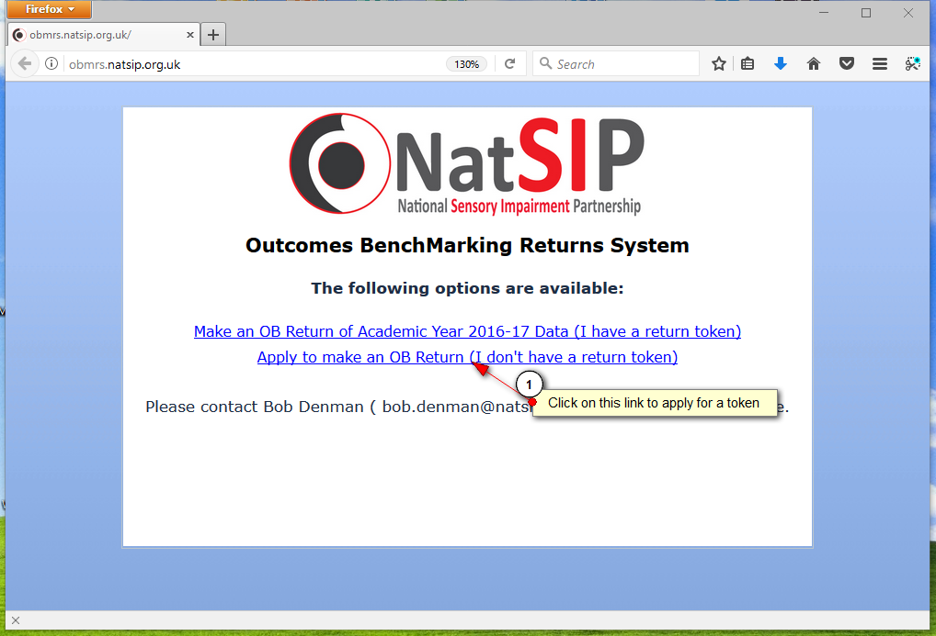

As shown in the image above, mouse-click on the ‘I don’t have a return token’ link.

You’ll see a web form:
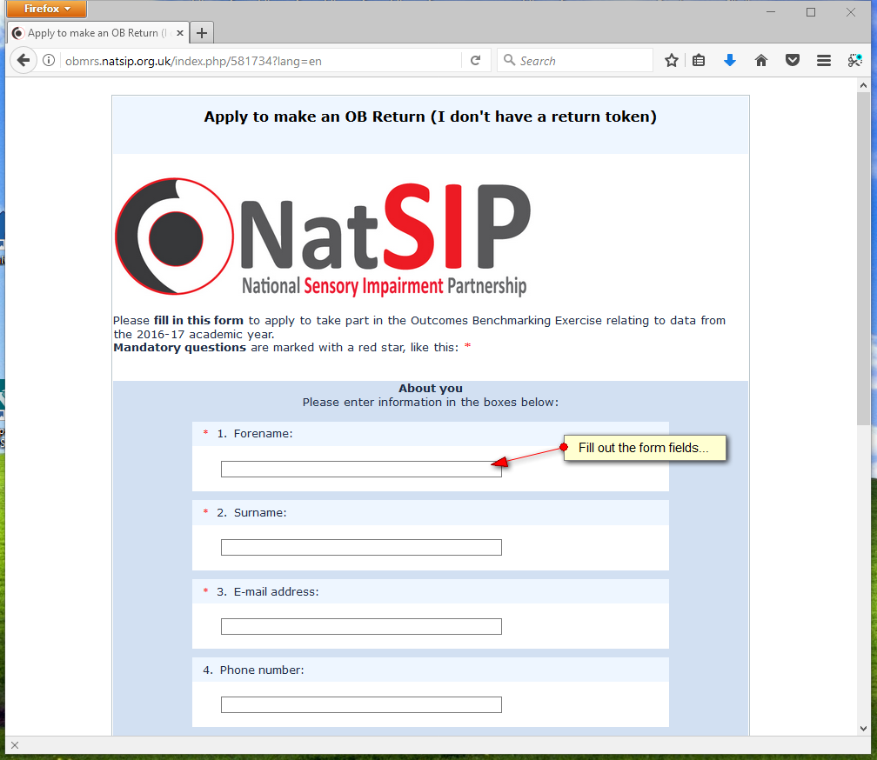
Note: Some form fields have built-in validation, and may appear pink if an invalid or incorrectly formatted input is present:
In the case above, the entered text does not conform to the rules for a valid email address. You may need to keep typing to complete your entry before the pink background disappears.

When you have filled in the form, it will look something like this:
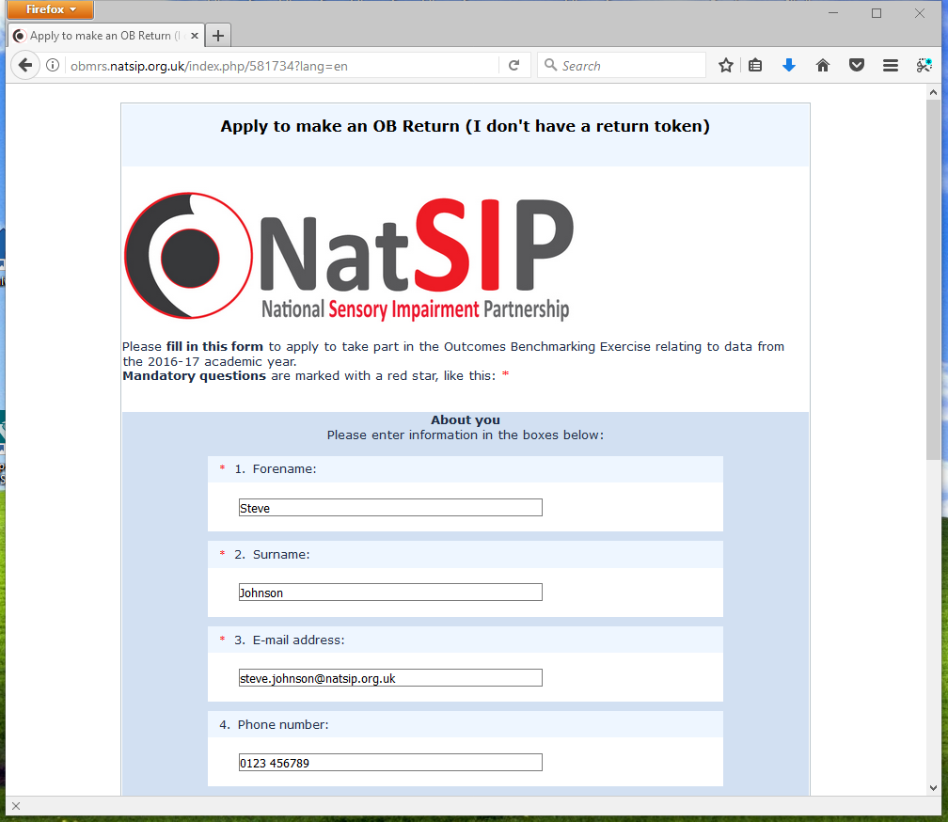
You will need to scroll down to see all of the fields.
At the bottom of the form, you’ll see a submit button:
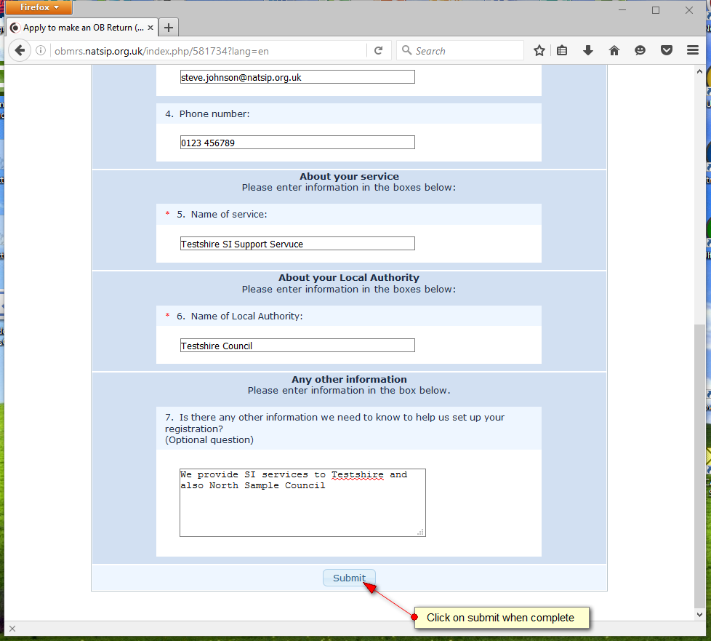

When you have submitted your application, you’ll see this screen:
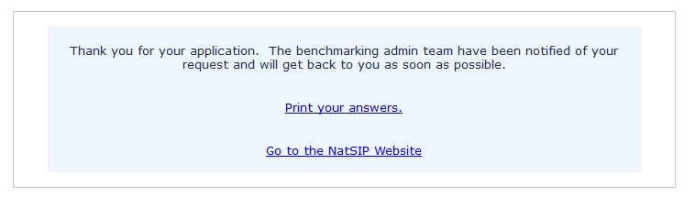
The benchmarking admin team will be sent an e-mail notifying them of your application. You should receive a reply by email.

5.1.2 Your token – Email ‘T’
Your token will be sent to you via ‘Email T’ which will look something like the image below.
[This is Outlook 2010 – your email program may look different]
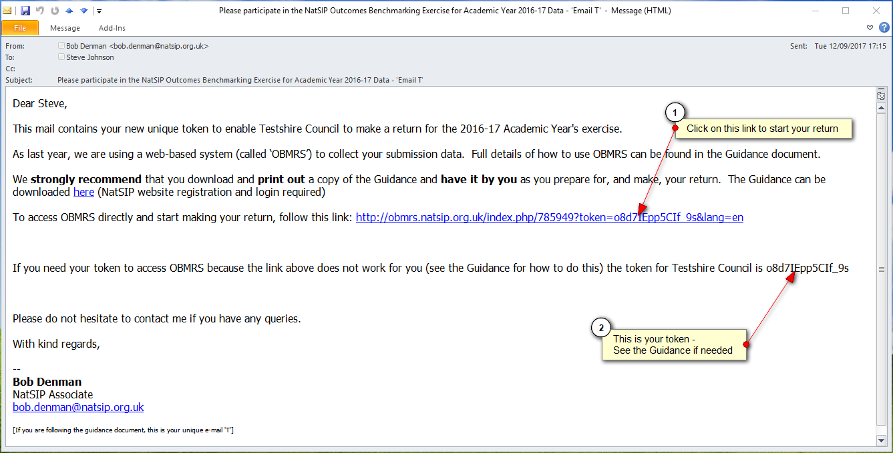
If you have received an email like this, you can click on the link, and follow the instructions below.

5.1.3 OK – I have Email ‘T’ and a token. How do I access OBMRS?
Simply click on the link in ‘Email T’ to access OBMRS (pointer 1 in the image above).

5.1.4 The link doesn’t work when I click on it…
If you can’t click on the link in the email, or it does not work (some LA IT systems restrict this function) then you will need to access OBMRS yourself:
Using a web browser (for example, Internet Explorer, Firefox, Chrome, Safari, Edge) go to http://obmrs.natsip.org.uk
You’ll see a screen similar to the one on the following page:
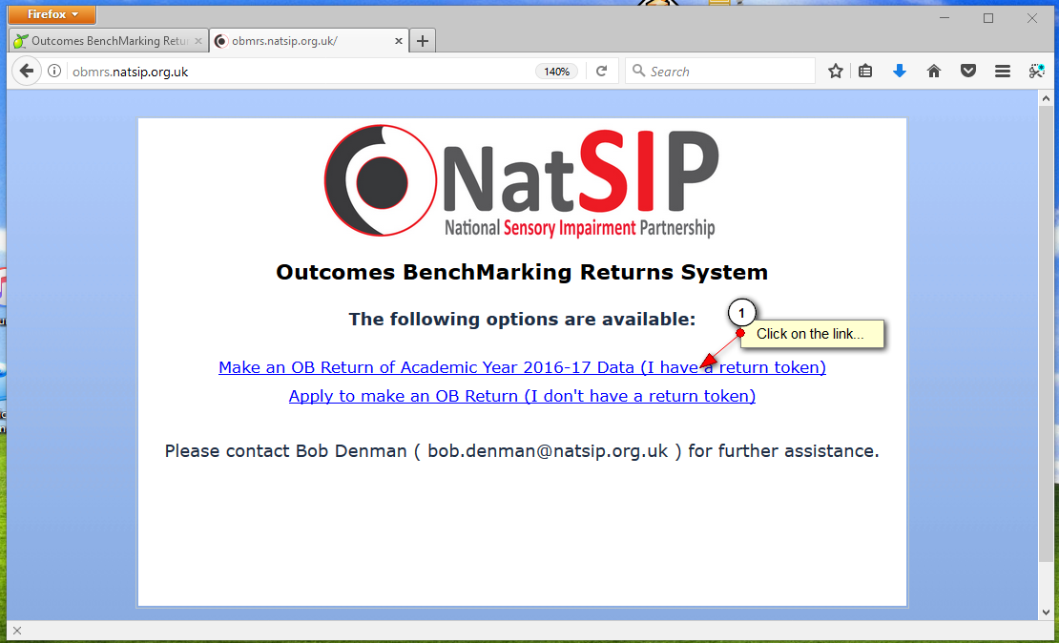
Mouse - click on the I have a return token link as shown above.
You’ll then see another screen:
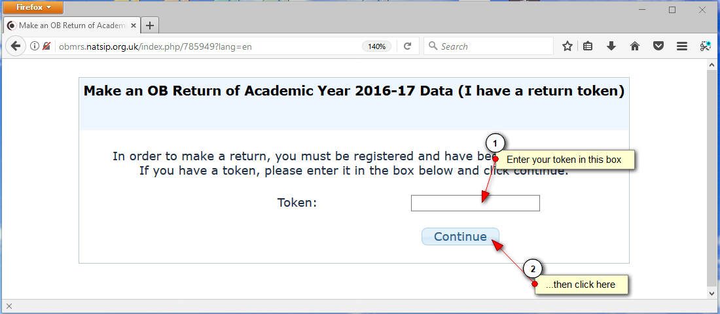
Enter your token (in the case of our example Email ‘T’ above, the token is o8d7IEpp5CIf_9s) and then click Continue.
Note: Tokens are 15 characters long, a mix of upper and lower case letters, numbers and punctuation characters and are case sensitive.
If you can copy and paste the token from email to the web form, rather than re-type it, that will make it easier.

5.2 The first OBMRS screen
When you have clicked on the link (or entered your token) you will see the first screen of the return:
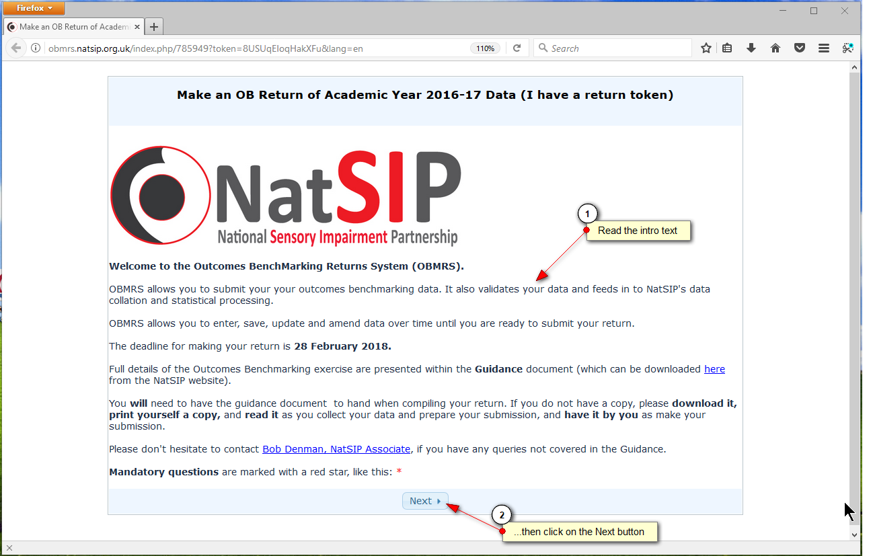
When you have read the introduction text, and clicked on the ‘Next’ button at the bottom, you’ll then be taken on to the first section of the return. See next page:

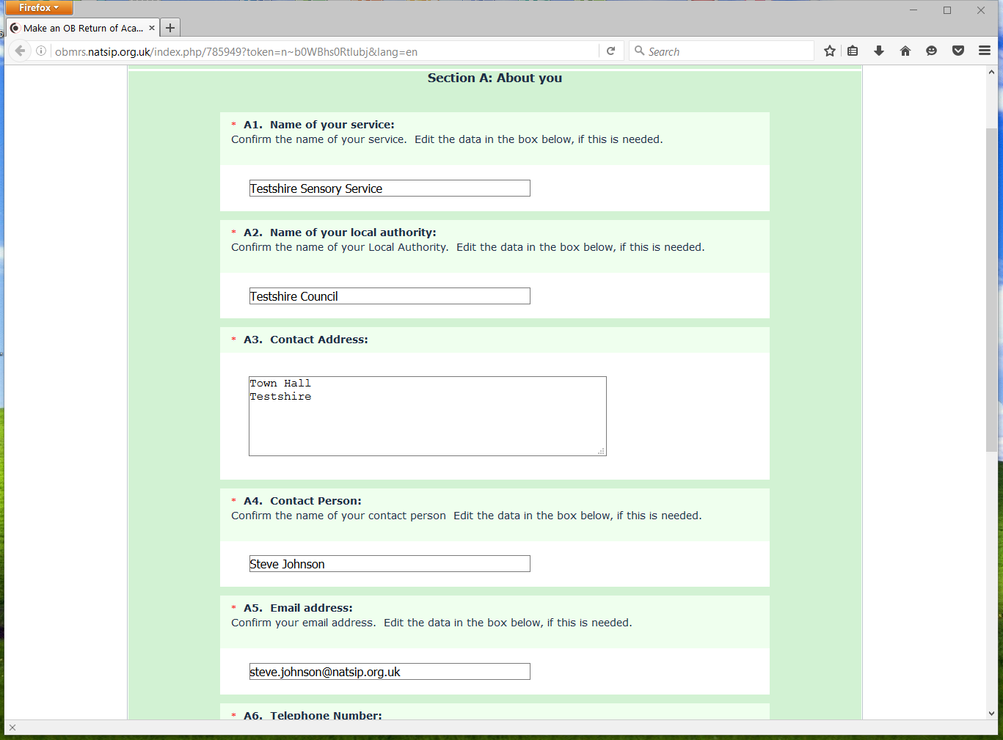
Note that some of the form fields may be pre-filled for you, depending on the data we have previously received. If this pre-filled data is not correct, please mouse-click into the input boxes to correct it before moving on.

5.3 What if I have data for more than one LA?
Where services cover a number of LAs, the data for each LA should be submitted on a separate return. If this applies to you, we will send you a separate token (in a separate Email ‘T’) for each LA. We ask for a separate return because the NatSIP analysis is performed by LA rather than Service or team.

5.4 What if I need to do a return for a single impairment/team? Can I do a partial return?
Can we do multiple partial returns for a single LA?
Some colleagues taking part in last year’s exercise reported difficulty co-ordinating all the data for all impairments into a single return, and would have preferred to be able to do a return for a single service or team, for example HI data alone, VI data alone.
If this situation applies to you, and you can co-ordinate with your colleagues, we recommend that you complete separate partial returns for each team for your LA. You will need a separate token for each return.
The Outcomes Benchmarking team will gladly assist by issuing additional tokens to your colleagues in other teams if this is needed, but we will need you to co-ordinate with colleagues so that we are clear on who is submitting data on which impairment.

5.5 What sections of the return do I need to complete?
The sections of the return form that you will be shown and expected to complete (i.e. HI, VI and MSI) will be determined by what you tell us in Question A8:
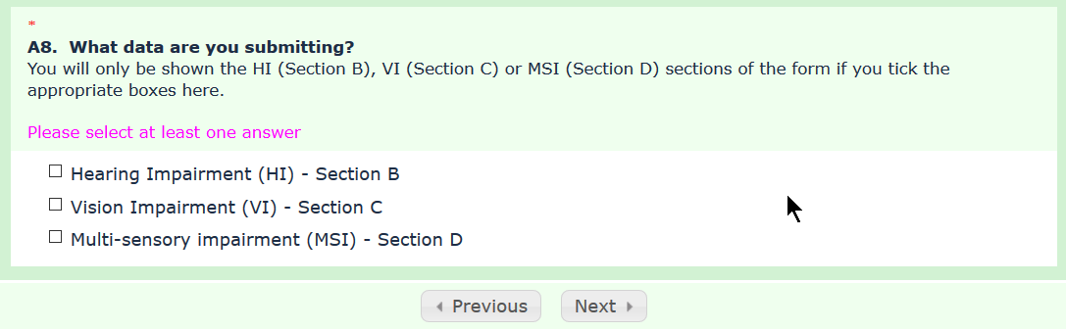
You must tick at least one box in Question A8. Your selected return sections will appear in sequence automatically. If, for example, you are only intending to submit VI data, tick just the VI box, and only the Section C: Vision Impairment pages will be displayed for data entry.
If you tick all three sections, and are intending to submit HI, VI and MSI data then Sections B (HI), C (VI) and D (MSI) pages will appear in that order.
See section 5.4 above for if you are planning to submit separate partial returns from different teams for a single LA. If this is the case, only tick the boxes for the sections you personally are submitting.

5.6 Question A9: Tell us about others who may be making partial returns for the same LA
If you are completing a partial return for only certain team(s) in your LA, and you are aware that others are making partial return(s) from other teams, please tell us about them in Question A9. The illustration below shows how you might answer this question:
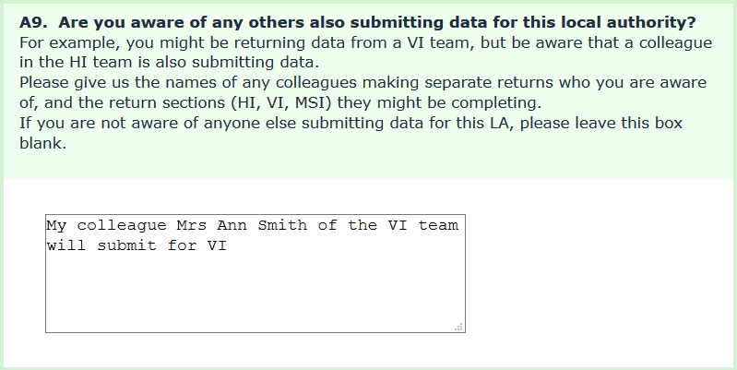
If you are not aware of anyone else making returns on behalf of this LA, please leave the question box blank.

5.7 Incomplete returns
Whilst it is hoped to gather the full range of data from as many LAs as possible, it is stressed that incomplete returns from sensory support services that do not have access to particular data or do not have the resources to make a full return will be most welcome, and will be of value in building the national benchmarking data.
What is critical in any return is that the specific data sets entered are complete i.e. the data is supplied for all the CYP in the relevant cohort. (If data from only a subset of a specified cohort was to be returned this would distort and undermine the reliability of the NatSIP benchmarking data.)
For example, in PI 10 (% of young people achieving the threshold in both English and mathematics in their GCSEs or equivalent at the end of KS4) it would clearly distort the PI value if only data for the young people who were entered for the exams was submitted as opposed to the whole end of KS4 cohort.
The exception to this guidance concerns CYP who live within the LA but who attend schools within other LAs – if their data cannot be obtained, this should not prevent the submission of data relating to the remaining pupils within the cohort.
Note: Non-existent data
In certain circumstances, data will not exist for all the CYP in a specified cohort, for example:
- a CYP may attend a private school that does not report the end of key stage results
- a CYP may have been absent for key stage tests
- a CYP may have moved into the LA without the required earlier key stage results being available
Where the data does not exist (as opposed to the service not being in a position to collect it) the cohort number can legitimately be reduced accordingly.

5.8 The on screen font size is too small…too large…
Remember that you can ‘zoom’ the text using your web browser. Usually this is [Ctrl]+[+] (Hold down the control key, tap the ‘+’ key) for zoom in (larger text) and [Ctrl]+[-] for zoom out (smaller text).
If you have a mouse with a scroll wheel on the top, [Ctrl]+Wheel Forwards, and [Ctrl]+Wheel Backwards usually function as ‘Zoom in’ and ‘Zoom Out’.

5.9 Data entry convention
The web pages of each section contain instructions on how to enter data:
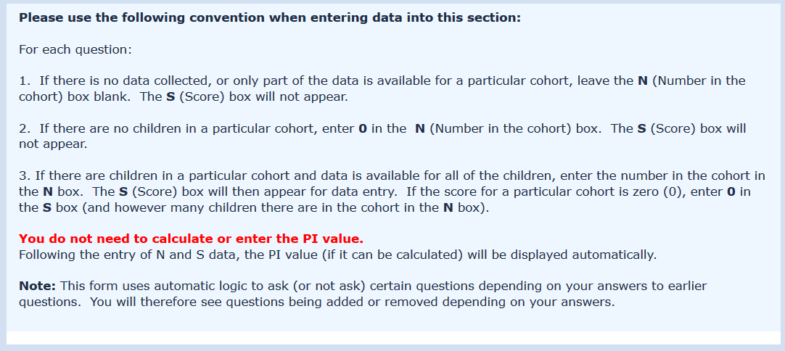
Please follow this convention when entering your data.

5.10 What happens when I start inputting data?
Before you input anything, the first two questions for the HI section will look like this:
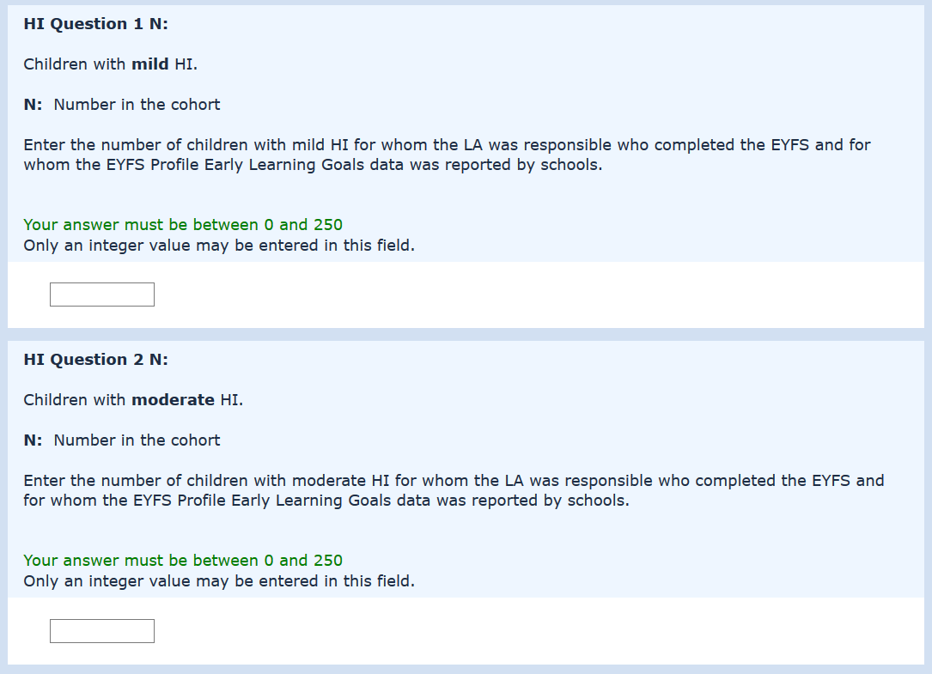
Note that only entry boxes for the ‘N’ value for each question are showing. If you do not have data for HI Q1, leave that question blank and move on to HI Q2. (See 5.9 above on the data entry convention to follow).
If you do have data for HI Question 1, enter the N value in the box.
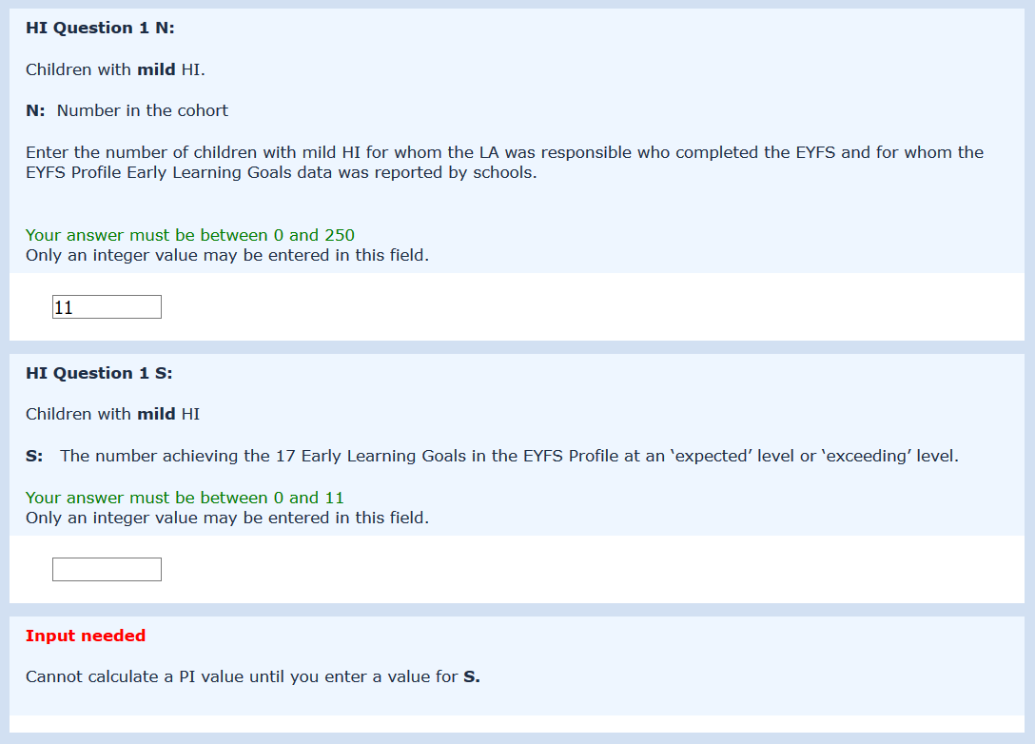
Note that once you have entered an N value, the S box for HI Question 1 is displayed. (You can’t have an S value until there is an N). Note also the Input needed prompt below the S box.
There is automatic validation for what you enter in S, which depends on what you entered as N. In this example, S can be equal to, but not higher than N. The validation rules for the question are displayed in green: ‘Your answer must be between… ’

If you enter an invalid value, a box will turn pink, and the validation rule will also turn pink:
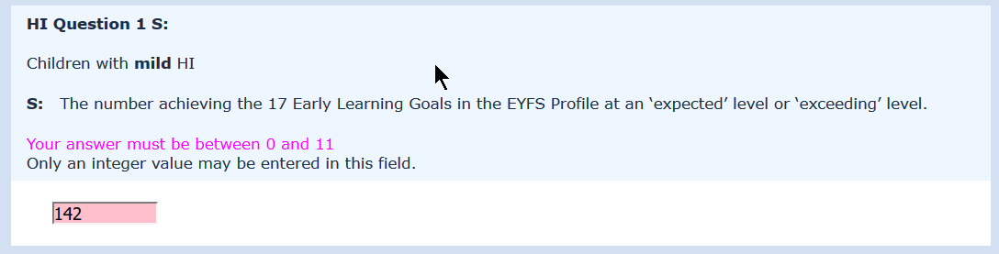
Use backspace to delete and then correct your entry.
When you have entered a valid value for S, a result box will be displayed:
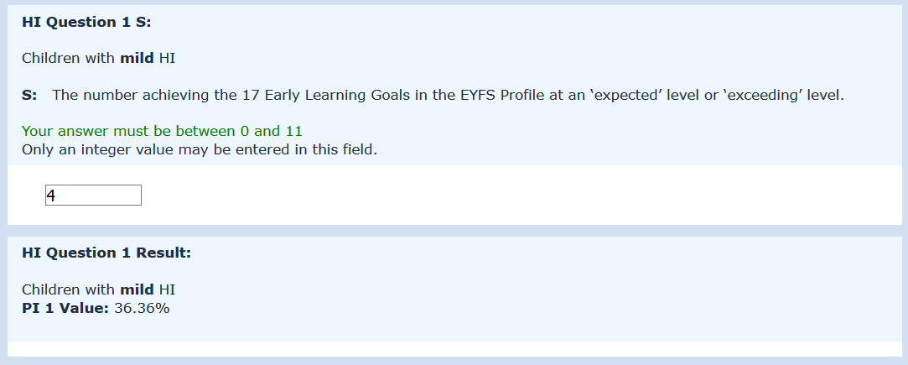
As mentioned in Section 5.9, you do not need to calculate or enter the PI value. OBMRS will automatically calculate and display the PI value (if it can be calculated) for you.
Now you have completed HI Question 1, scroll down to see HI Question 2…. and so on through the sections.

5.10 Stepping through the pages of each section
At the bottom of each page, there is a set of buttons:
The <Previous button takes you to previous page (if there is one).
The Next> button takes you to the next page (if there is one).

5.11 Mandatory questions
Note that you cannot go to the next page until you have answered all the mandatory questions on the page you are on. If you miss out an answer to a mandatory question, you will see the message:
by the question(s) you need to answer.

5.12 Saving your data input without submitting
OBMRS allows you to save your input so far, without submitting your return, and come back to it later. This means that you can visit OBMRS as many times as needed to input your data. You don’t have to do all your input in one long (and exhausting) session.
To save your data, mouse-click on the Save and resume later button at the bottom of each form page:
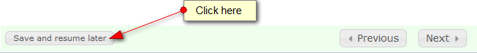

Your data will be saved, and you will see a confirmation message
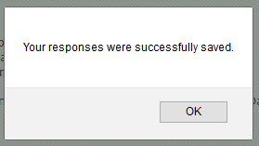
Acknowledge the message by mouse-clicking on the OK button. You can then close your browser, and go and do something else.

5.13 Picking up where you left off
To come back to OBMRS where you left off, simply repeat what you did to access OBMRS in the first place – either click on the link in the email we sent you (Section 5.1.3) or input your token yourself (Section 5.1.4). You will come back to your partially completed return form.

5.14 Navigating the return - The Question Index
As you work through the pages of each section, you will see the sections being added to the Question Index to the right of the data input pane.
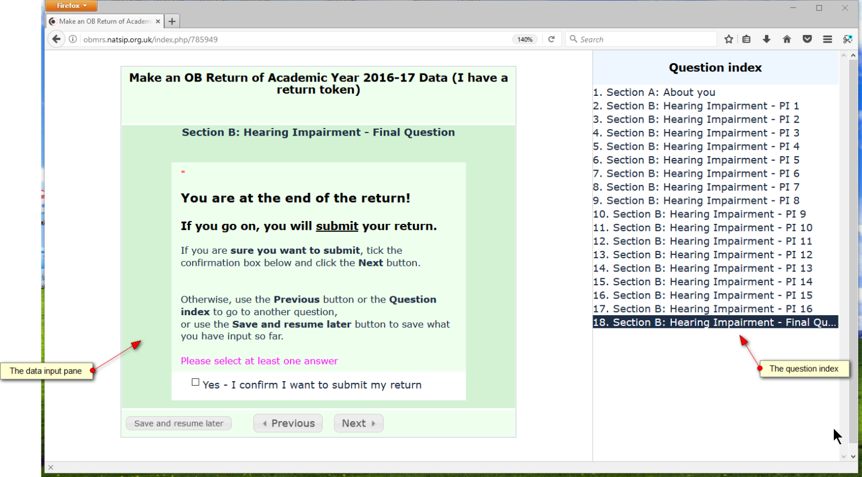

Questions only appear in the Question index as you read through them and advance through the return using the Next button. This is because OBMRS uses automatic logic to determine which questions to display, and later questions depend on earlier questions, so you can’t jump forwards!
Once you have reviewed any question, you can then jump back and forward freely by clicking on the headings in the question index.
The questions displayed in the index are preserved if you Save and resume later (see Section 5.12), so you only have to work through the return once.

5.16 The final question – or how not to submit without meaning to…
Following feedback from users, we have added a new final question to the OBMRS which appears when the next mouse-click would submit your return. The question looks like this:
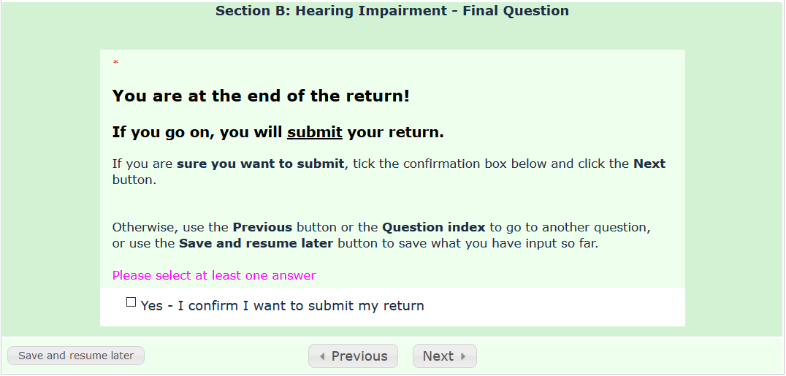
You will not be able to submit your return until you have checked the ‘Yes – I confirm…’ box, and clicked on the Next or Submit button.
This question will appear at the end of Section B, Section C or Section D depending on your answer to question A8 (see Section 5.5 above).

5.17 Submitting your return
When you have completed and are ready to submit your return and do not intend to make any further updates or amendments to your submission, answer the ‘final question’ (see previous page) and click on the Submit or Next button at the bottom of the last page:
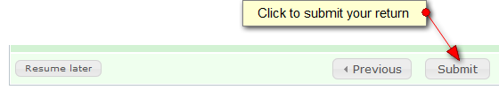
Once your return has been made, you will receive an email confirming your submission. The confidential report of your LA’s results will be forwarded to you with the NatSIP Outcomes Benchmarking Report at the end of the exercise (ref s6.3).

5.18 Help! I didn’t mean to press submit!
In response to feedback from last year, it is now possible to make multiple submissions to OBMRS. If you make an error, simply go back in to the OBMRS (see Section 5.1.3), change the data entered and re-submit.
OBMRS will always consider the last submission by date/time to be the definitive one. (All submissions are time/date stamped when they are logged on the OBMRS server).

5.19 When is the submission deadline?
Submission of your return can be made any time up to the end of February 2018. If you have difficulty meeting this deadline, please contact bob.denman@natsip.org.uk.

6.0 How will the results be reported?

6.1 Contents of the NatSIP report
A full report of the benchmarking exercise, which will be confidential to the participants, will be sent electronically to each of the sensory support services involved. The report will be split into a number of sections to provide:
• The separate HI, VI and MSI sets of results
• A comparison of HI, VI and MSI results
• Trend data through a comparison of year on year results where data is available
• A comparison of the NatSIP outcomes data with that for all CYP published by the DfE (to provide evidence in relation to the aim of closing the gap in attainment)
• An executive summary

6.2 Treatment and presentation of the data
The analysis contained within the main report will show:
• The average (mean) PI scores for CYP collated across LAs for each of the defined SI categories
• The average (mean) PI scores for LAs, along with the standard deviation of the scores (a measure of the spread of the scores). LAs will be coded to retain their anonymity. (Each sensory support service will be issued with its LA code(s) when the report is forwarded)
Apart from the presentation of results in tables, the report will display results in chart format where appropriate. A commentary on the findings will also be offered.

6.3 Service results
For benchmarking purposes, each service will receive a separate report, confidential to the service, showing its PI results for the LA(s) covered by the Service which can be compared with the extensive data in the full report. This will be forwarded with the NatSIP Outcomes Benchmarking Report at the end of the exercise.

6.4 Directory
A Directory of Participants to facilitate contact between the sensory support services involved and to promote discussion over benchmarking issues will be prepared.

6.5 When will the main report be made available?
The NatSIP report, individual service report and directory will be made available to each of the participating services by the end of June 2018 at the latest. As stated in s1.7, prompt submission of data by the end of February 2018 from all services intending to make a return should enable the report to be released in the first half of the summer term.

6.6 Summary report
A brief, summary report will be prepared for wider circulation and posted on the NatSIP web site. This will not identify participant SI Support Services or individual SI Support Service results.

7.0 Confidentiality and data security
Only service level data, as opposed to individual pupil level data, will be submitted for benchmarking and, furthermore, individual sensory support service results will only be disclosed to the service providing the raw data.
NatSIP is not a public body and is therefore not liable to Freedom of Information Act (2000) requests. However, our contract with the DfE requires us to comply with FoI requests made through them.

-- End of Document --

https://www.natsip.org.uk/index.php/doc-library-login/outcomes-benchmarking-guidance-forms/1113-03-inidividual-pupil-data-collection-form-hi
https://www.natsip.org.uk/index.php/doc-library-login/outcomes-benchmarking-guidance-forms/1114-04-individual-pupil-data-collection-form-vi
https://www.natsip.org.uk/index.php/doc-library-login/outcomes-benchmarking-guidance-forms/1115-05-individual-pupil-data-collection-form-msi
https://www.natsip.org.uk/index.php/outcomes-benchmarking/docman-data-collection
https://www.natsip.org.uk
NARA Braille files can be accessed via the Load2Learn website: http://www.load2learn.com Information on NARA can be found at http://www.gl-assessment.co.uk/products/neale-analysis-reading-ability

